**FARMISTAR: Cultivating Sustainability in Agriculture, Triumphs as Global Champion for Call for Code 2023 Global Challenge**



Ayan Ghosh with his Father & Mother | Picture courtesy : OWN

**The Rise of FARMISTAR: Confronting Agricultural Challenges**

Nestled in the heart of West Bengal's Burdwan, where agricultural traditions run deep, a lone innovator embarked on a transformative journey. Faced with the escalating challenges plaguing the farming community—unpredictable climates, resource inefficiencies, and struggles of small-scale farmers—the need for a solution was dire.

Enter FARMISTAR, a brainchild nurtured by dedication, perseverance, and an unwavering commitment to revolutionize agriculture. Crafted solo, this visionary solution emerged triumphant in the esteemed Call for Code 2023 competition, hosted by IBM, the Linux Foundation, and the UN Human Rights, catapulting into the global spotlight for its ground-breaking impact on sustainable farming practices designed & developed by Ayan Ghosh.

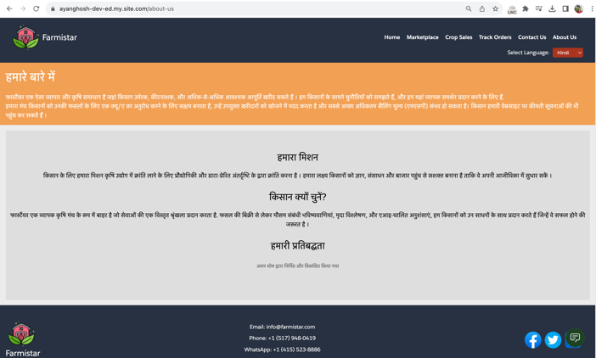**From Regional Finalist to Global Triumph: FARMISTAR's Journey**

The accolades began with a regional finalist title, earning a well-deserved $10,000. Yet, it was the momentous win of the global grand prize of $50,000 that cemented FARMISTAR’s legacy. This triumph didn’t merely symbolize victory; it validated the transformative potential of a solution born from sheer determination and innovation.

**FARMISTAR: The Winning Solution**

At its core, FARMISTAR is a technological marvel fuelled by AI prowess. It optimizes crop yield, minimizes resource wastage, and tailors recommendations for crops and fertilizers, fostering sustainability while promoting responsible farming practices—a dire need in today's agricultural landscape.

**Championing Resilience: Weather-based Solutions**

The critical pillar of FARMISTAR lies in its weather-based decision-making capabilities. Providing farmers with real-time insights and adaptive strategies, it enables them to navigate the tumultuous waves of unpredictable climate shifts, safeguarding crops and livelihoods.

**Global Impact, Local Empowerment: FARMISTAR's Reach**

The impact of FARMISTAR transcends borders, reaching farmers worldwide and transforming agricultural paradigms. Yet, its essence remains rooted in empowering local communities. It champions fair trade, provides a marketplace for small-scale farmers, and streamlines communication among stakeholders, nurturing a network crucial for sustainable agriculture.

**The Triumph of Innovation: FARMISTAR's Legacy**

FARMISTAR’s victory isn’t merely about technology; it’s a testament to the power of innovation and determination. It’s the story of a solitary innovator from Burdwan, West Bengal, whose vision and dedication birthed a solution that redefines the future of agriculture—a future that harmonizes technology and empathy for a more sustainable world.

**Conclusion: Harvesting Success, Sowing Inspiration**

The journey of FARMISTAR from regional recognition to global triumph stands as an inspiration—a testament to the transformative potential of dedication, innovation, and a fervent commitment to sustainability. This triumph is not just a win for an individual but a victory for the entire farming community, promising a landscape where technological advancement nurtures compassion and resilience.